MATH 315

Mathematical Modeling

Assignment 12

Due Wednesday, October 23
Read Section 7.3 “Competing Species” in Chapter 7: Nonlinear Differential Equations and Stability of Brannan and Boyce Differential Equations.

Problems

7.3 Bifurcation Exercises: 12, 15, 17
(Read Introductions/Instructions Which Precede Exercises)

NOTE: There is a typographical error in the equation for $y’$ in Problem 12.
It should read $y’ = -4x + y +x^{2}$.

Pictures Below: Direction Fields Near (2,2) for System
$$x^{'}=x\left(4-x-y\right)$$
$$y^{'}=y(2+2a-y-ax)$$

a = 3/4  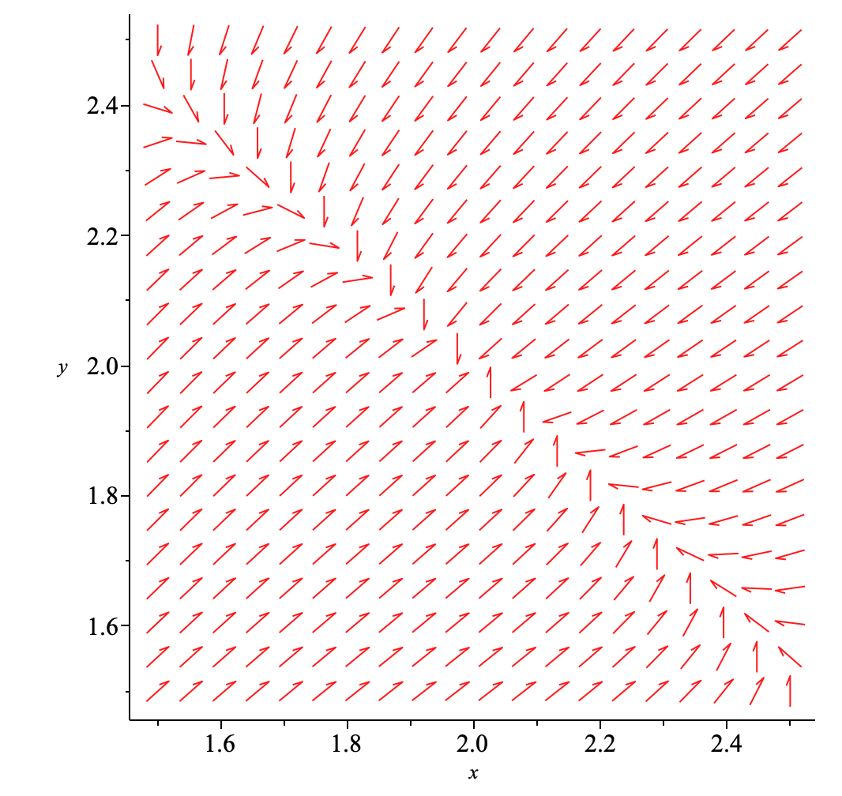 | a = 5/4  